What I Learned From Fr. Clay…
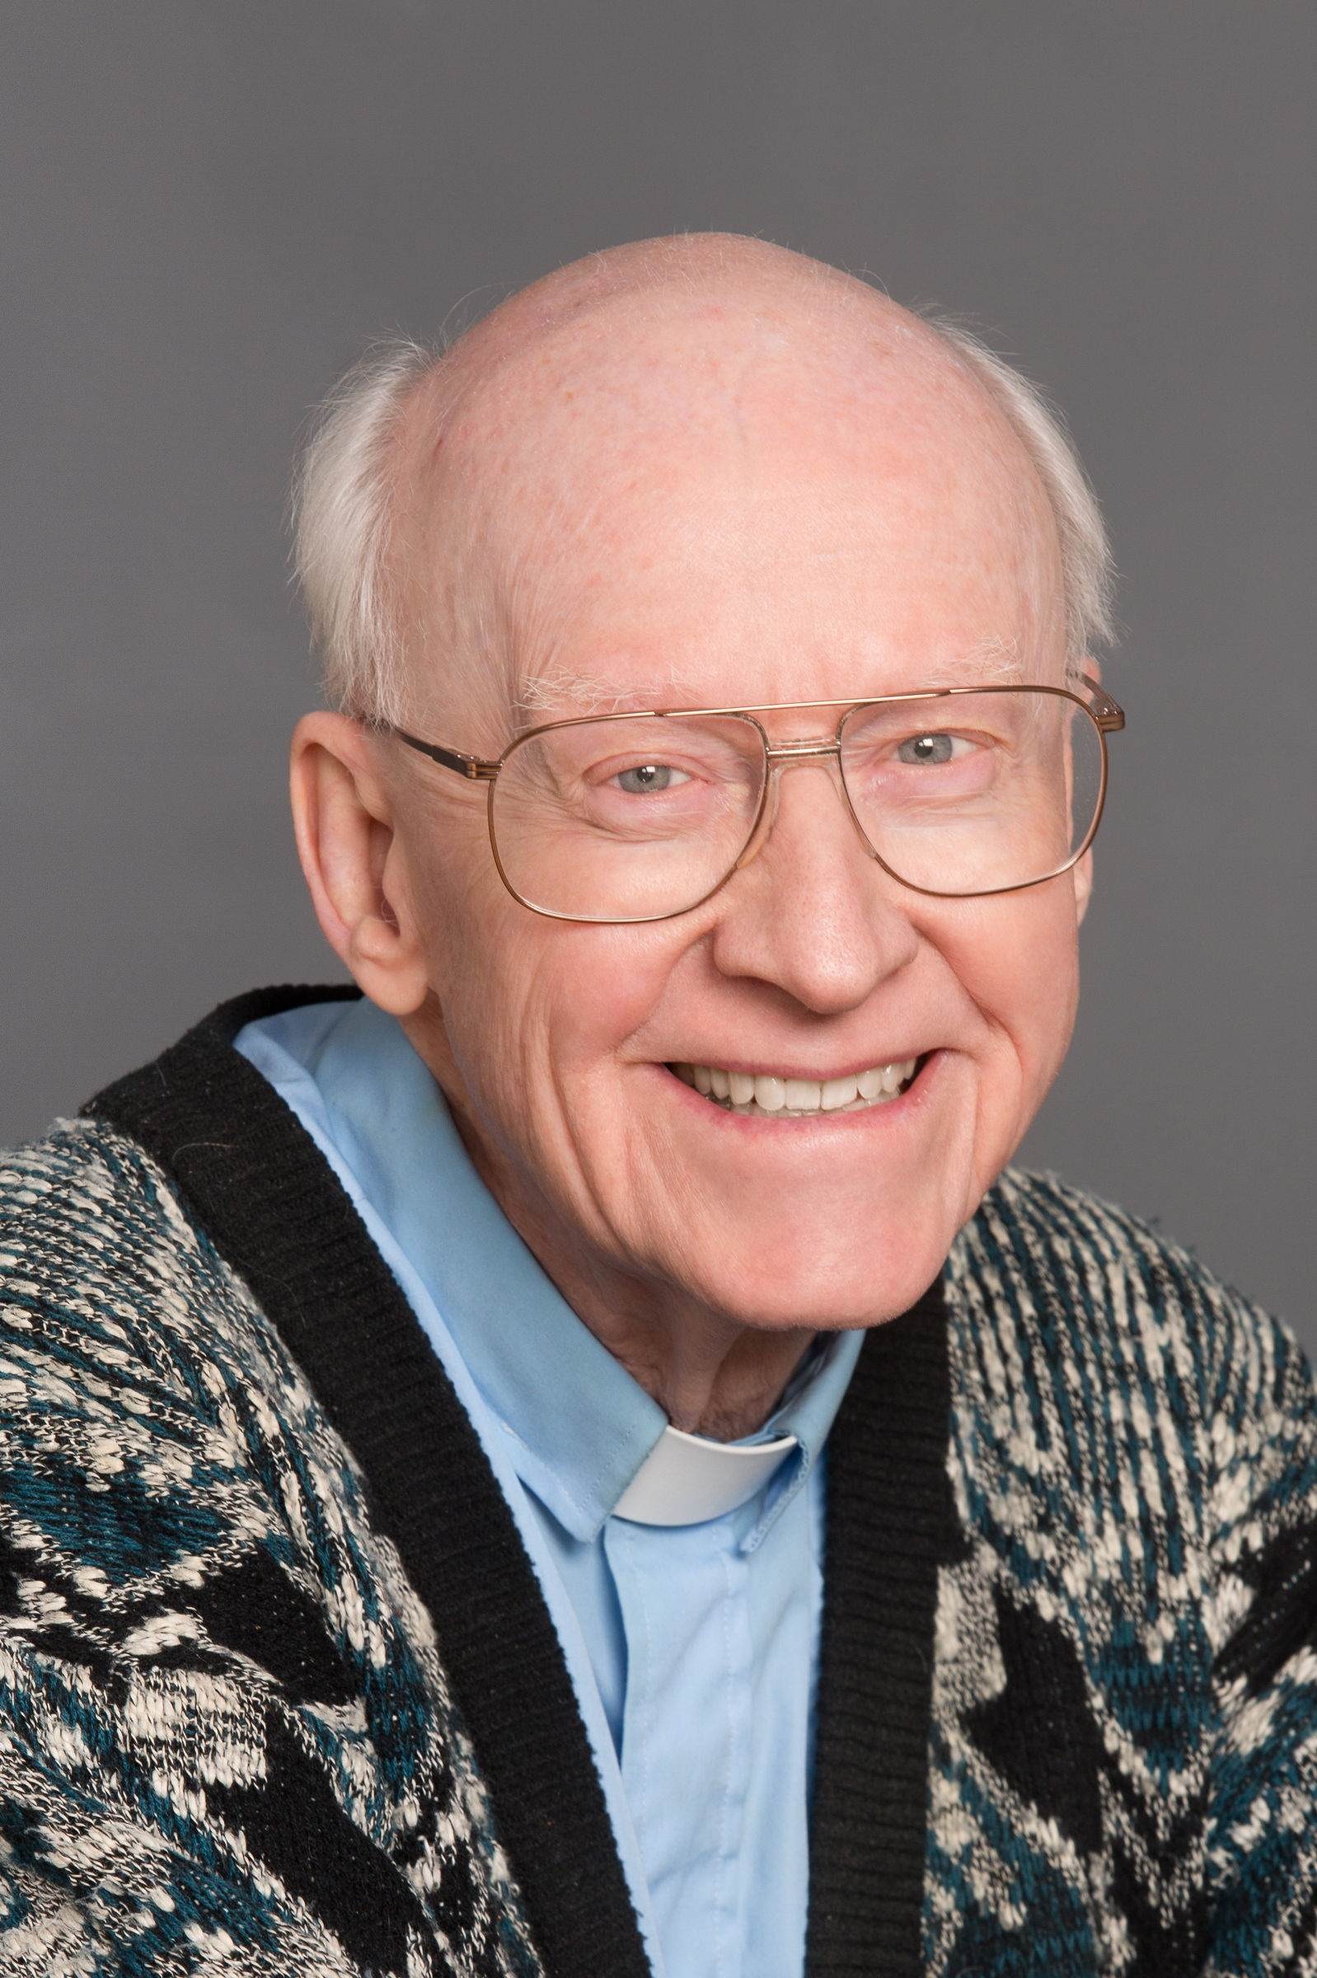

That every sin is forgivable. The sin/s is/are bad, I am not. Father Clay taught me so much: to listen, to love, not to judge and to remember to pray and check in with God, even a simple prayer to let Him know I’m OK.
Father Clay taught many prayers. One of my favorites is: “Jesus, help me to be the person you created me to be.”



I learned love and forgiveness. Dear Father — you give me your love, and you forgave my deepest sins. My wife and I are so grateful for meeting you and miss you at church. I pray for you everyday and will continue always.



To love!



I learned to “…smile, God loves you.” Just as you are, not for your beauty or your power or your wealth, but you, child of God who is Love Itself. You can’t become Holy/Good all on your own… You can’t forgive all on your own. Only surrender to love and let God who is Love love you.



Smile, God loves you.
God is love.
To sit quietly each day and just let the love that God is surround you.
That we can’t try to be perfect and not sin. We must ask God for help. We are human — we aren’t perfect.
We are all God’s children. He loves us all. None of us are better than anyone else. It doesn’t matter what religion we are — what profession we do — how much money we have — God loves us all.
I learned about the seven cardinal sins and how God gave them to us as they are needed. But we must use them in the right way. We need God’s help to do that.
I learned how important it is to love one another and how much Father Clay loves us (AND WE LOVE HIM TOO!!)
I learned that God loves us no matter what we’ve done as God is love. We need God’s help to not sin.
We are all beautiful … It’s just easier to see in a baby getting baptized!
We love you Father Clay!



Father has taught me to believe love is the greatest gift God has given us, God is all-loving, and God forgives us of all our sins. Father does not make the rules of God, and teaches us that the sinners are the ones that need the church the most. The reason to go to church is not to brag “what a good person I am” to everyone, but instead we should go to God’s house in love — sort of the way we visit a loved family member. I love and miss John very much. I wish him the best.



I learned that God is love. We are all loved. Love unto others as God loves us.



I learned what love and kindness really mean.



Never be judgmental. To always treat people equally, regardless of their status, and to love one another. Love you, Fr. Clay.



What I learned was always be kind and no matter what always remember:
Jesus Loves You!
And we love you, Fr. Clay! Thank you for all you have done!



I think he is the most compassionate man that I know. To me, he is what I think God would be. There should be more people on Earth like him.



God is love.
God loves everyone.
Goodness flows from love.
So …
love everyone,
do everything with love.
Happy retirement, Fr. Clay!



What do I take away from my encounter with Father Clay? He taught me by many examples to be accepting of others,
to be kind,
to love myself so I could love others,
to forgive myself.
I asked him once how was I to know if a choice was the will of God or just a bad decision on my part. He said that none of us can be sure what the will of God is in a situation.
His words touched people. When my family came to church here, they always remarked that it seemed like he was speaking directly to them. He did that for me Sunday after Sunday and I knew not to take it for granted.
He taught me it was OK to be me just as I am, that God loved me just as I am, but to keep trying to do better and love better. “Jesus, you love me and accept me with my flaws and sins, only say the word and my soul will be healed.”



Thank you, Father Clay, for blessing and honoring our love by marrying us (when no one would) in 1995 — God bless you as you have richly blessed us!



To love and forgive one another. To be humble and reach out to someone who seems to need a shoulder to lean on. To remember God loves me for who I am.



Congratulations on retirement. Enjoy! What I always liked was the sermons. It was like you were in our house listening to problems we had over the years with kids and ourselves and families. What you said in your sermons made everything better, and living church made me feel everything was going to be good, and you made me feel happy. Father Clay, I will miss you.



Congrats on your retirement — we will miss you. We’ve been members of St. Stan’s since late 1979 and it has been a blessing for our family. Fr. Clay is the first priest I ever knew that was human and able to admit he had faults and sinned, too.
I learned how open-minded, fair and accepting he was. He truly loves all.
He helped our family through some difficult times and showed me that I can and should move on to grow as a loved person.
He helped save our marriage because of his caring guidance. Father is a wonderful, caring and loving man. Compassionate and understanding, too! We have been truly blessed over all these years. Thank you for everything.



My wife and I were married by Father Clay in 1999. During the service, Father gently offered us some words of wisdom. First, don’t try to change the other person. Second, don’t smother your partner. Give your partner all the room she needs for becoming the person she wants to be. Now, twenty years later, Father’s words on that day continue to serve as marital bedrock for what has turned out to be a very loving and healthy relationship. Thanks, Father Clay.



We are relative newcomers to St. Stan’s, discovering it while looking for a parish where we would be happy to have our kids do their First Communion. I remember very clearly meeting Fr. Clay and asking if we could sign our kids up even though we weren’t parish members. His response: “You’re people, aren’t you?” Between that and attending our first Mass — where we saw an 87-year-old priest beaming as he made his way around the entire church, shaking everyone’s hand, paused for a two-minute meditation during the sermon, and listened to a message of hope and love — we knew St. Stan’s was where we wanted to be. Even in the few short years we have been at St. Stan’s, Fr. Clay’s impact on myself and my family is difficult to put into words, but in particular I would like to thank him for three things:
- For the inspiration I received in watching someone who truly loves what he does and who operates in such a kind and gentle manner;
- For getting me to realize that there is only one thing in life that matters (and yes, I needed to be reminded of it every week!!);
- For making me, my wife, and our three kids feel special every time we saw him.
Father Clay, thank you from the bottom of our hearts!!!



The love God has for us
That can be shown
To others by allowing
That love to come in
To our hearts by
Centering Prayer
Service
Community.



God is love.
God is beautiful.
Ask God to transform you into what he wants you to be.
Trust in God.



I learned that the Catholic faith and Church can be very inclusive. I think that is the way Jesus would have it. Thank you, Fr. Clay. You were very giving of your time. We will miss you greatly!



I gained a greater understanding of what it is to be, and to live, as a Christian man. Fr. Clay’s message of love helped me at a time when I was somewhat lost, and I try to pass on that message as often as possible.



I came to my faith life due to Fr. Clay. No other church had really accepted me the way that I needed, but St. Stan’s was wonderful. Fr. Clay has taught me so much about God, and he has prepared a foundation for a lifelong faith life for me. Thank you, Fr. Clay!



God is love. If you believe that, everything else will work itself out.



How to forgive and let go of my anger.
How not to judge others.
Admit to my mistakes — don’t blame others.
How to pick up my cross and carry it.



That I am loved no matter my actions, flaws, or wrongdoings, and that I am always forgiven. I AM LOVED.



“The world is more than I will ever know. We are an unfolding of light and matter. We give expression to the universe.” — (Fr. Pierre Teilhard de Chardin, one of Fr. Clay’s favorite authors)
Fr. Clay has helped me change my image of God, to seeing the creator as a huge force of self-existing love, dependent on nothing. Creation is God choosing to share a bit of this love with all in the universe. It is this love which holds everything in existence. With the Big Bang we were all born of and from loving energy.
He taught me love is the fiery energy flowing through me and everything ever created. Matter and spirit are one. Love is the only important element in the entire universe. This loving energy always goes to connecting. It is constantly creating, expanding and evolving in us. We are hardwired for relationship, belonging and love. We belong to God and to each other.
My job is to be open and vulnerable, to let go of myself and trust in God and grace and the Paschal Mystery. Love does the rest. “It is done unto me.”
And I can begin this great love by going out into the world with some understanding of what it means to welcome the stranger and love my enemy. Amen.



Fr. Clay has given me a language for a mature spirituality. He has expanded my vision to help me take in how much I am loved and this love will always be beyond my understanding and at the same time is the core of everything. “Thy will be done.” He describes the Salvation Story as I need to face my sin and know I am deeply loved all at the same time. The more I allow love in, the more I feel my humanity. So I laugh and cry, feel sad and experience joy, and am open to welcoming God always and everywhere. So fall in love and let others love me. Offer random acts of kindness. It always helps to remember that the goodness and mercy of God is always bigger than any of my flaws and sins. Smile God, loves you. Amen.



Fr. Clay,
He talks to us,
He is gentle and kind,
He tells us he loves us.
Oh my God, this love that washed over me,
it makes me want to be better.
With a grateful heart, Amen.



Father Clay has taught me that God loves me more than I could ever imagine. He has taught me to be open in prayer and to believe in His mercy and to leave room for miracles.



God loves me just as I am.
Do not try to be too holy.
All the so-called “Capital Sins” have a place in our lives — only when out of balance do they become a problem.



Compassion. I was looking for a church to get married in and my sister recommended I speak with Fr. Clay. It was a snowy afternoon when I met Fr. Clay shoveling outside the rectory. I told him my situation, and he stopped shoveling and invited me inside to talk about it. I was taken aback by how much time he gave me without knowing me. Our subsequent marriage counseling with him also emphasized how “God is Love,” and just to carry His love throughout our interactions in life. God bless Father Clay.



God loves each one of us. No matter what.
Patience, Love, Forgiveness
To forgive another is to bring healing to yourself. God shall judge.
No matter what I’ve done wrong, negative, etc, I can repent and ask forgiveness. Even if it happens over and over again.
On more than one occasion, my siblings and I were discussing religious/family issues, leaving many questions unanswered. Fr. Clay unknowingly answered our questions with his next sermon. This happened several times! We became parishioners.



No matter what wrongs I’ve committed, God always loves me.
Father Clay taught me to forgive myself.
Father Clay taught me to love.
Everyone was born pure and innocent and when I have difficulty seeing love in others, remember that God looks upon each with 100x the love that I looked upon my daughter with as a baby. God is love. Love is all.



All people are God’s people.
God understands all his children make mistakes. Teaching all people to learn and forgive. Father Clay teaches me the face of an infant is the closest to God. Innocent.



First, it was his acceptance of all people that led me back to the church. I consider it a great gift that he facilitated.
Second, I learned more about love, acceptance, humility, and how important it is to show these things not only to our loved ones but to all of God’s children.
I love Father very much and I hope you know how great of an impact you have made to so many people. Father is the pebble that sets off infinite ripples.



1) Fr. Clay taught me I am loved by God — no matter how I view myself, to God I am as cute as that little baby. He taught me much about humility and entitlement. “I’m standing in front of you all dressed in this ‘holy’ outfit.” If it were not for so many people and God in my life, I could be behind bars. And if the person behind bars had been born into my family and privilege, he would probably be standing in front of you in this outfit saying loving words. Fr. Clay smiled and said, “God loves you.” Later he added “and I love you too.”
2) Story of vanity and humility, of the two women who went down to the seashore to swim. They both took off their clothes and left them on the shore. One came out first (vanity) and took the other’s nicer clothes and left only the rags, which humility then put on. Can’t remember the punchline. He taught me to laugh, especially when I can’t remember something.
We need to listen to people who are different than ourselves, those who have another life perspective than we do, in order to learn something.
3) At funerals he often said, “Don’t worry if the person forgave you or not. There is only love now.” Do not judge yourself or others harshly. I don’t have the whole story about them or myself. I cannot fully know why I think or say or do what I do. Only God understands me and them totally. Story of the “dots” the others put on me and eventually the dots will all fall off. As I truly begin to love myself, as I trust I am loved.
4) “We are surrounded by love, the love we name God. That love holds us, embraces us, cradles us, looks at us tenderly and with compassion. That love lives deep within our souls and bubbles up with powerful, healing energy.” “The utter spark of God.” “Let the cares, the worries, the fears, the hates, the anger, the vengeance, the cruelty, the bitterness, loneliness, despair and depression fall away. … Help me to surrender myself to you and rest in you.” Surrounded by God, p 126-127.
5) When I was a young person in another church, I had made a mistake and was being reprimanded loudly by the other priest. Fr. Clay walked by and smiled at me after he had gently touched my hand in compassion. Twenty years later when I came to St. Stan’s, I thanked him for helping me a lot at that painful moment in my life. He smiled again and said, “I think I recall that time and am glad I was there at that moment for you.”



I’m a slow learner, but over the years since I joined St. Stan’s Parish in 2005, I came to hear and accept that God loves me, no matter what. I learned from Fr. Clay that the (too) many bad choices I’ve made in my life did not turn God away from me; that I remain a Child of God and worthy of God’s love. This strong message from Fr. Clay has changed my heart and my life. Thank you, Fr. Clay.



I learned all I had to do was ‘show up’ and God’s grace takes care of the rest.



At the first Mass I came to some 30+ years ago, I felt welcomed and accepted by Fr. Clay and the people of St. Stan’s.
Fr. Clay helps me believe and trust that God loves me with all my quirks. Fr. Clay listens to people. He cares. He shares his insights and beliefs in a gentle way.
Fr. Clay has helped me through some hard times by listening and reminding me to let go. I cannot control others. And also he has me say the words “thy will be done” and beg for help to see and trust that all will be well.



Nothing is more important than love. God is love.



Thank you for teaching me the simplicity of life. I have learned to love myself and others. Of course, I know above all, God loves me. Thank you for your unending love, support, and wisdom. May God bless you always!



I learned from Fr. Clay on how to live a life of service.
I also learned the importance of humor.
I learned to give to others from the heart.
I learned Jesus’s promise that the kingdom belongs to everyone. Live right and trust God.



I learned the lesson: when I try to do things perfectly, I don’t leave room for God.



I learned that God will forgive you for sins you have made and that God will not judge you. Fr. Clay did a very wonderful service for me and my family when my mother was passing away. I learned to love everybody and love them no matter what color they are.



Fr. Clay taught me that religion is simple. We just need to love one another. Never judge anyone because we don’t know their story. No sin or offense is greater than the Love God has for us! Rejoice, for we are forgiven! Guilt helps no one!



 e □  Stanislaus 20 years ago with my brother and his family, only for a couple years (if that). I very much appreciated his sermons. The Masses gave me peace after so many years. So 20 years later, here I am. I was surprised and comforted that Fr. Clay was still here. Then I learned he retires in a few weeks. He has reminded me of discipline (40 years!), devotion, kindness, and community. In my darkness I tread cautiously but I am heartened that with endings come beginnings, that with discipline and devotion comes community. Best wishes to Fr. Clay in his new beginning.



I learned that God loves us (everyone) and that we need to love everyone. This is so important as we are living in a very divided nation — we all think our point of view is correct whether it concerns politics or the Catholic Church.



Fr. Clay shows a lot of patience when he talks and when he listens. I’m trying to grasp that habit.



When he speaks about God, he takes us to a deeper level of spirituality that we might not have been aware existed. If this analogy makes any sense: others talk basic physics and are good at that; Fr. Clay goes to the quantum level. We are in awe of the depths of spiritual life, and we are in awe of the incomprehensible vastness of God’s love. It makes us want to be better people.



Father Clay taught me (us) that God is Love—a greater Love than we can ever imagine. God’s love feeds us and fills us up. All we have to do, and this is the hard part, is to be open to that Love and Allow It into our hearts. It’s a slow process as Father willingly shares some of his experiences as examples to help us. A way of telling us what to expect in our own journeys. I feel that with Father’s help I am more on that journey than ever before. The St. Stan’s Parish family reaffirms that love. Father married my wife and me. We asked but he said “Why do you want to bother with all that—in the eye of God you’re already married.” Please Father marry us anyway, and we want the blessing you say after your homilies. Oh and we have a bag piper too. Don’t play it in church—might damage the sound system. Our wedding was wonderful. Thank you Father Clay.



I consider knowing Father John Clay to be one of the greatest treasures of my life. His all-inclusive embrace of all people is infectious. Because of him I have found healing and forgiveness for my brother. His generous sharing of himself and his vulnerabilities has helped not only me but many others. I am reminded to look for and find the Love that is God in my fellow man however different from me they may be. His Loving guided meditations following his homilies were key to Letting God in. I will miss his guidance in these, but he has given us the tools to continue on our own. As he often reminded us, he “has a long way to go…” and so do we, but we have been Lovingly placed on the path. For this and more, I feel so very blessed and grateful to have been in the presence of Father John Clay. God bless him!



So much that I can't completely express it, but here are some basic things that have changed my life and my outlook:

-God is a powerful loving energy that keeps trying to work in us and thru us (not a being as we may conceive it).

-God loves everyone--all people, of all religions and no religion.

-Sometimes the best prayer is to sit quietly and let God love us....we should say thy will be done, and listen for answers rather than telling God what to do for us.

-God loves us and forgives us even though we sin; there is nothing we can do that will make God stop loving us.


Father Clay taught me that we all deserve a place at God’s table. He made me feel I was loved and that we all sin but we are all forgiven. I feel like I belong at St. Stan’s and I have Father Clay to thank for that. He is truly a holy and humble man.

— Memories collected from parishioners in April & May 2019

